Application of Scenario Discovery Techniques to Probabilistic Ensembles

1. Introduction

-traditional scenario discovery

-probabilistic ensembles

-value of combining approaches

1. Methods

2.1. Summary of probabilistic ensembles

2.2. Scenario discovery techniques employed (Kenny’s text on CART and feature importance scores…)

1. Input-Output Mapping: Drivers of Renewable Electricity Penetration

3.1. Global Share of Renewables in 2050 under Reference

-results Kenny already has in his draft: CART, parallel axis, hyper-parameterization results, importance scores…

3.2 Global Share of Renewables in 2050 under Policy

-Importance scores for Share of Renewables in 2050 under Policy (Paris2C)

3.3 Global Share of Renewables over Time?

-Results from Dynamic SD for Global Reference and Policy?

3.4 Regional Differences

-Share of Renewables in 2050 under Reference in China, USA, EUR

-Share of Renewables in 2050 under Policy (Paris2C) in China, USA, EUR

-let’s look at parallel axis/importance scores for these

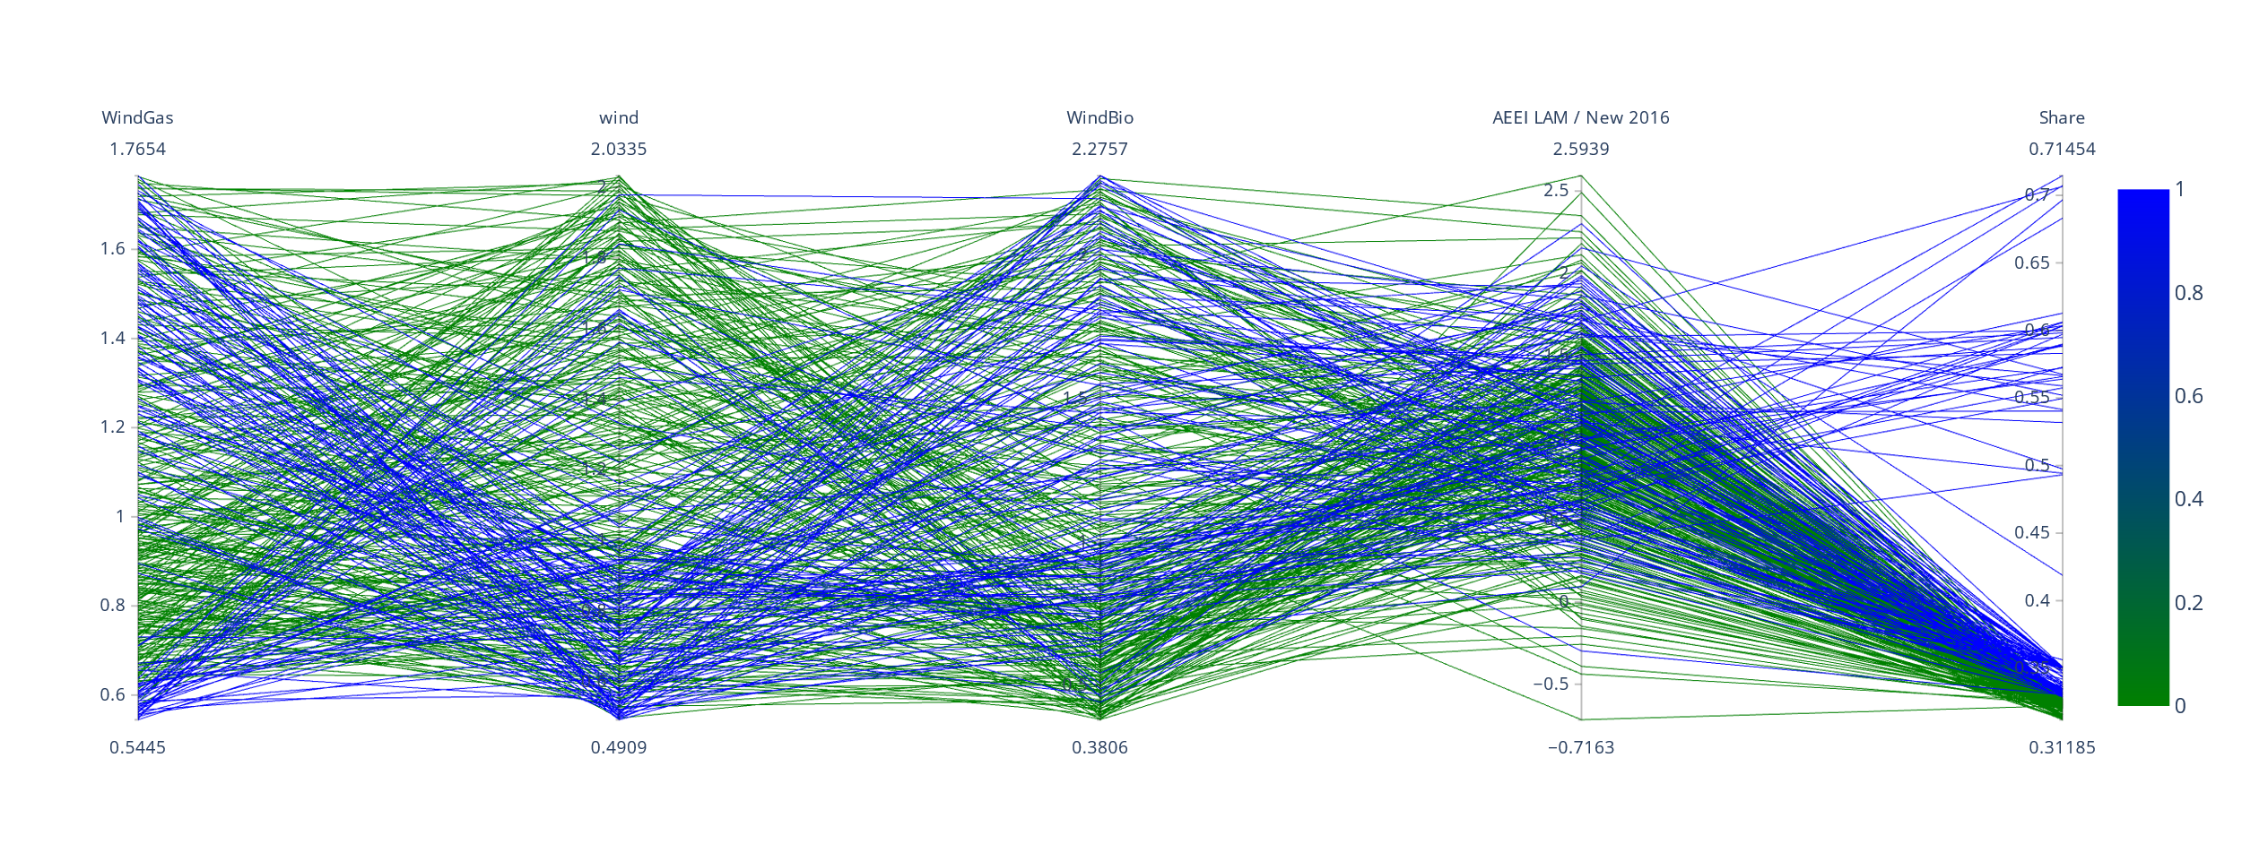

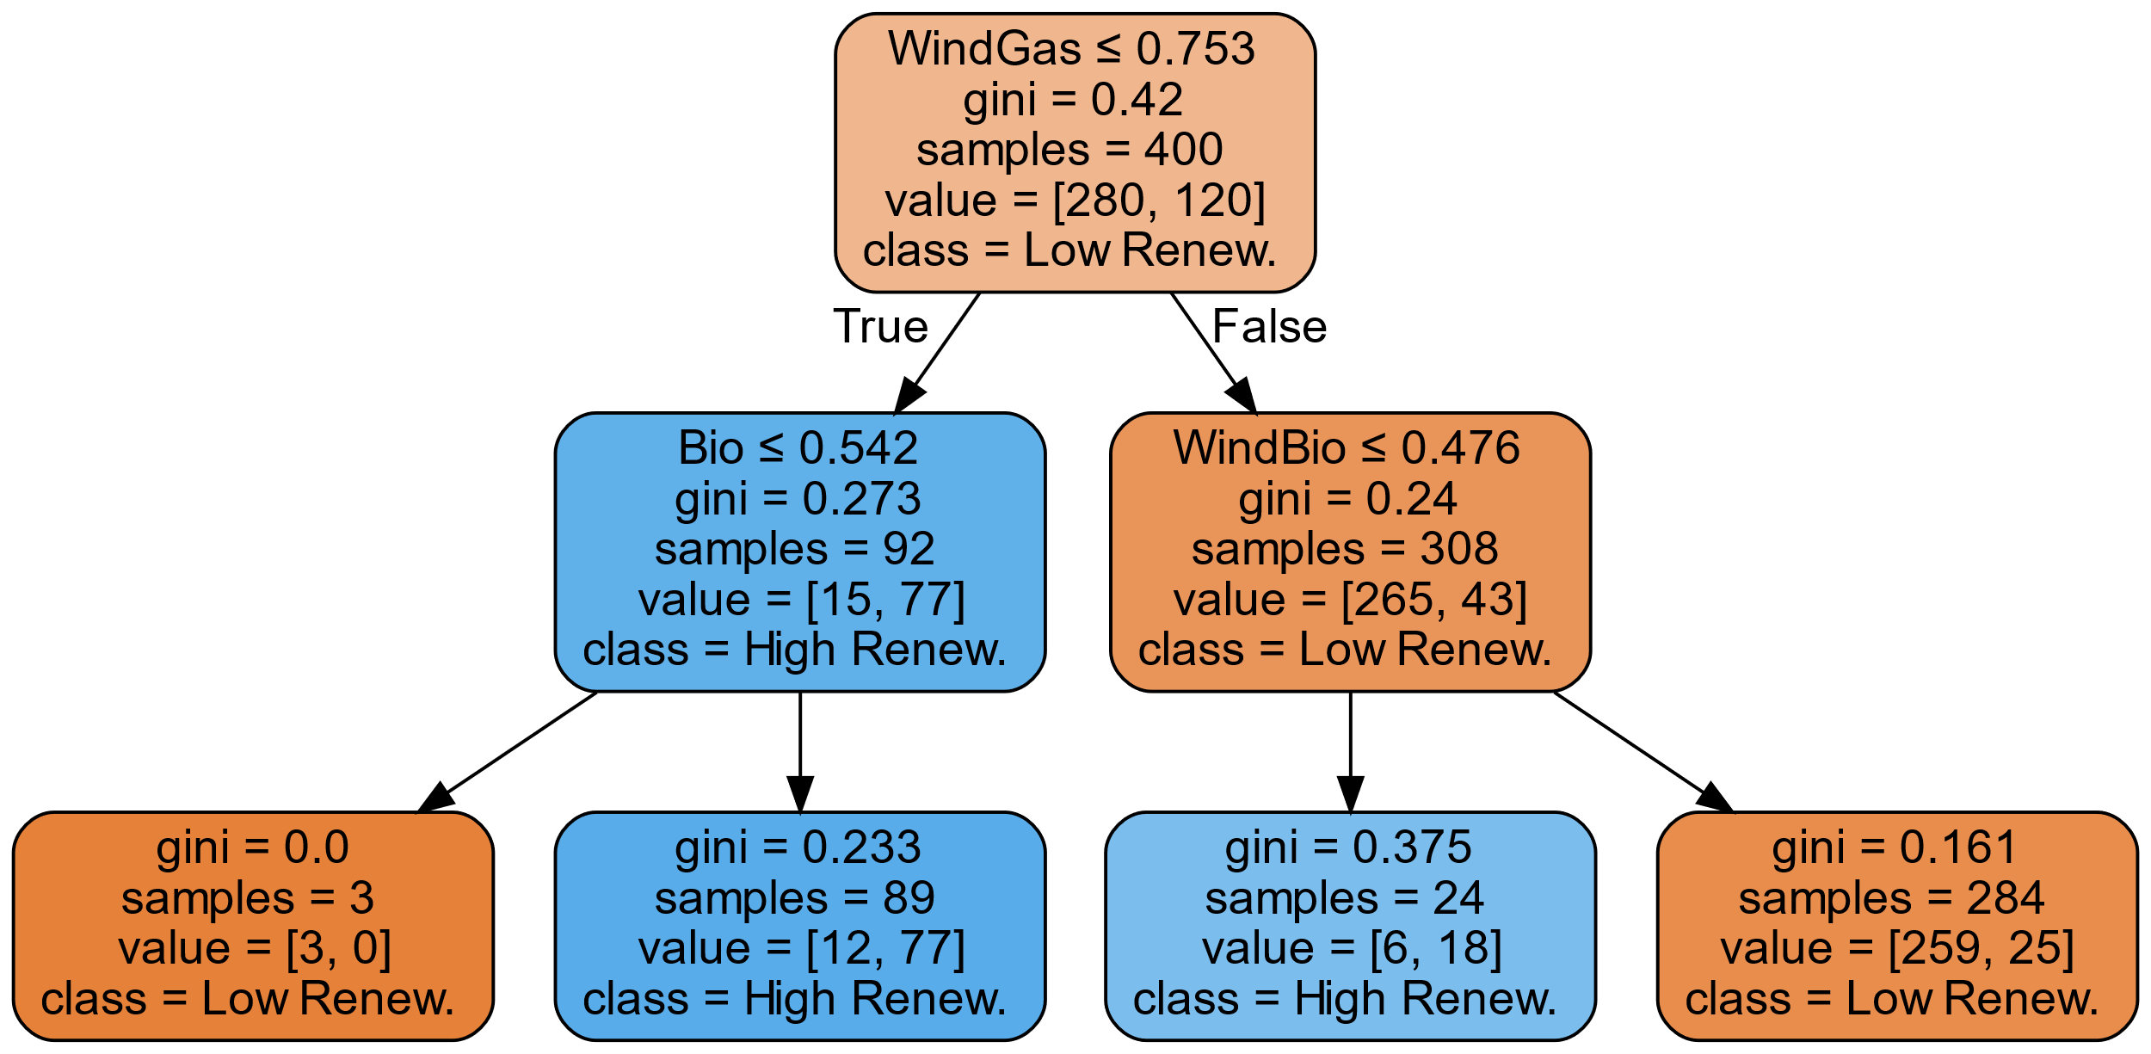

3.5 Discussion

-Key drivers can vary significantly based on region or time period of interest… important to not pick them a priori

-Value of connecting to probabilistic interpretation

1. Output-Output Mapping: Relationships Between Endogenous Outputs

4.1. Relationship between Renewables in China and Other Outcomes

-Share of Renewables in 2050 under Policy (Paris2C) in China: CART, parallel axis, importance scores…

4.2. Relationship between Emissions in China and Other Outcomes

-Emissions in 2050 under Reference in China: CART, parallel axis, importance scores…

4.3 Discussion

-Insights

-Value of connecting to probabilistic interpretation

1. Conclusions

-Key drivers can vary significantly based on the output, region or time period of interest… important to not pick them a priori

-Value of combining methods

Drivers of Income Gap??? Include in this paper as another example of Input-Output mapping? Explore in separate paper?